35.1: Measuring with a ruler from both 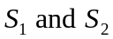to there different points in the antinodal line labeled = 3, we find that the difference in path length is three times the wavelength of the wave, as measured from one crest to the next on the diagram.

